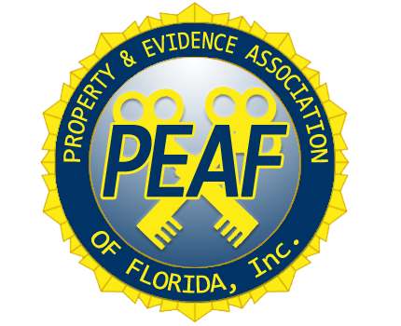

**Register through the PEAF website:** [**www.peaf.net**](http://www.peaf.net)

**Educational Conference: May 05, 06, 07, 2025**

**Certification Class: May 08, 2025**

**Certification Test: May 09, 2025**

**Educational Conference**: $350.00 until March 8th; $375 March 9th to March 29th (Shirts will not be guaranteed with late registrations.)

Includes: 3-day Training Conference, one PEAF shirt, one dinner, and 1-day Certification Class (if applicable). *Note: Test is an additional $150 fee. Additional guest dinner ticket is $75

[Multiple attendees from one agency will receive a $50 discount: First attendee is $350, each additional is $300. *Must register at the same time to provide discount. *]

**Certification Class & Exam Only:** $250.00 until March 8th / $275 March 9th to March 29th

Includes: Certification Class, Certification materials, and Certification exam

**Certification Test Only**: $150.00 until March 8th / $175 March 9th to March 29th

**Hotel Room Rate**: Wyndham Orlando Resort & Conference Center, 3011 Maingate Lane, Kissimmee, FL 34747 rate $129.00

<https://www.wyndhamhotels.com/wyndham/kissimmee-florida/wyndham-orlando-resort-and-conference-center-celebration-area/rooms-rates?brand_id=HR&checkInDate=5/4/2025&checkOutDate=5/10/2025&useWRPoints=false&children=0&groupCode=050425PEA&adults=1&rooms=1&loc=ChIJ5wsVNxqE3YgRDcL9EZfN55Q&sessionId=1717607747>

**Early registration is open until March 8, 2025.**

**Late Fees apply for conference, class and test from March 9 to March 29, 2025.**

**Registration Closes March 29, 2025. No Registrations or Refunds after March 29, 2025.**